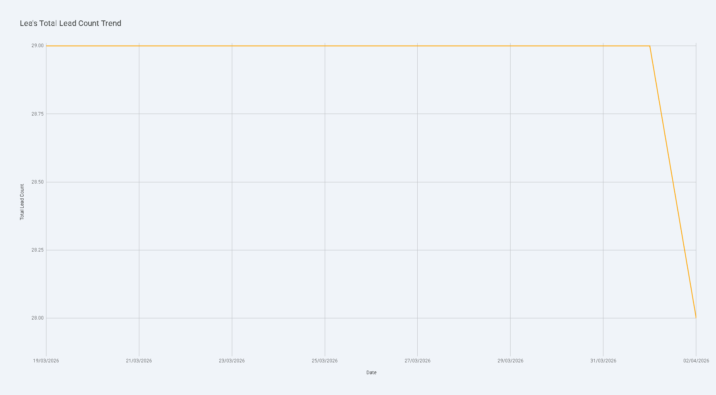

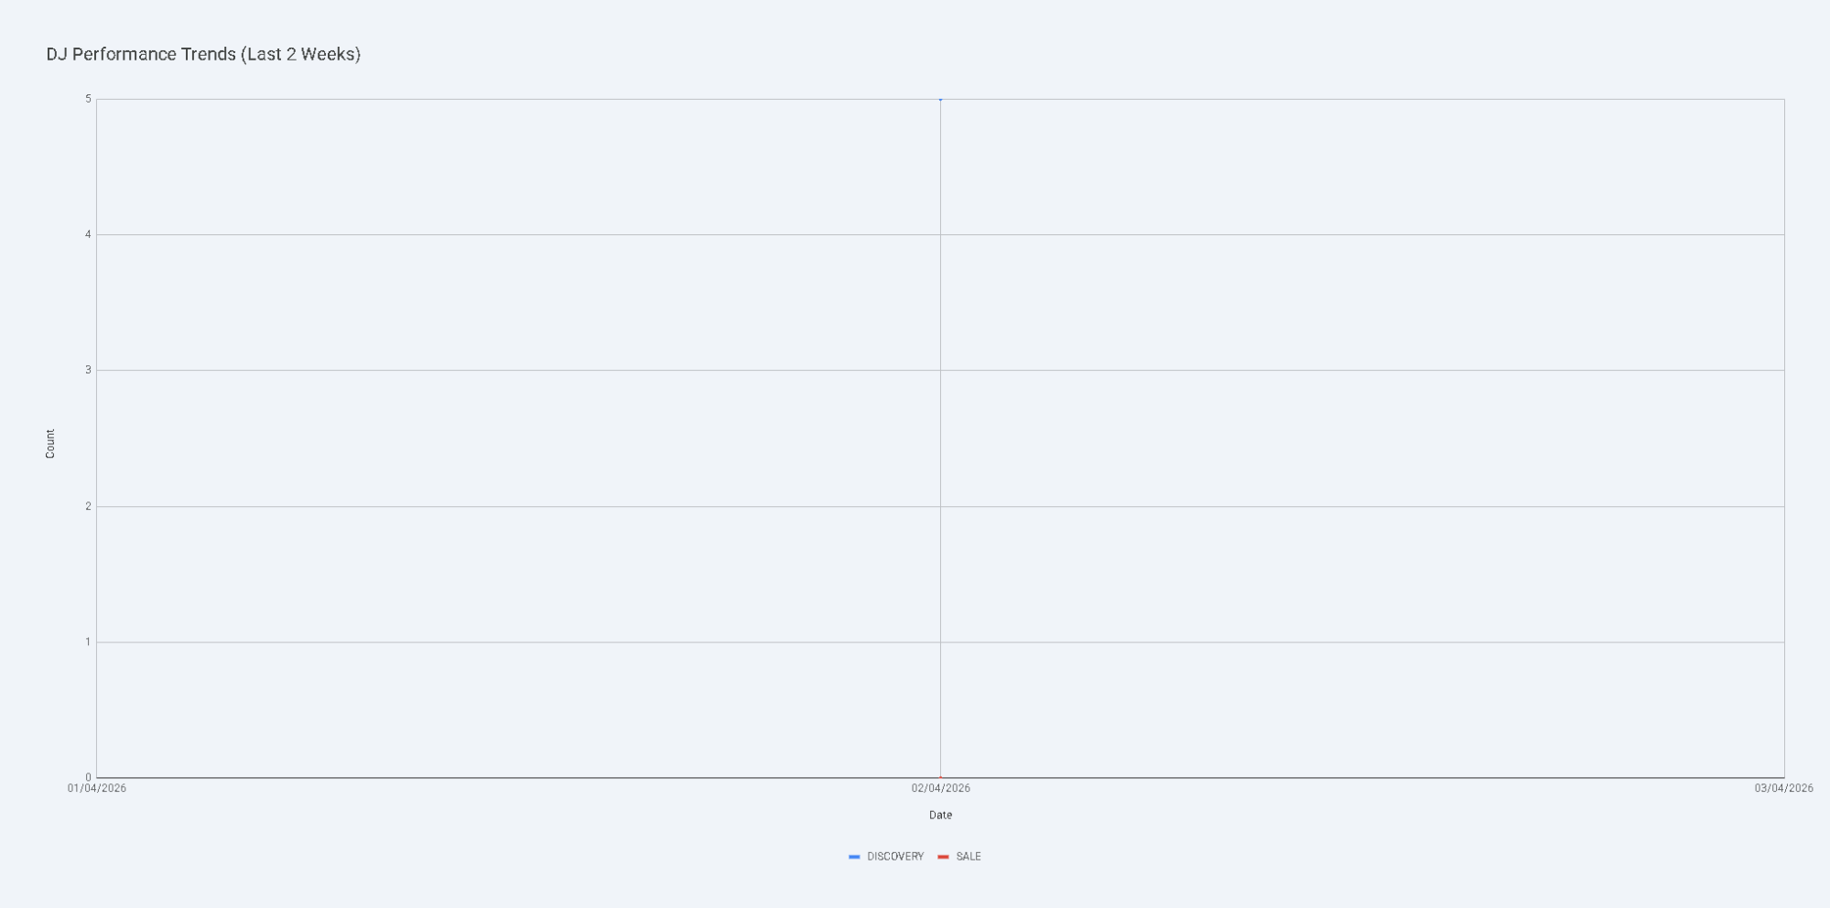



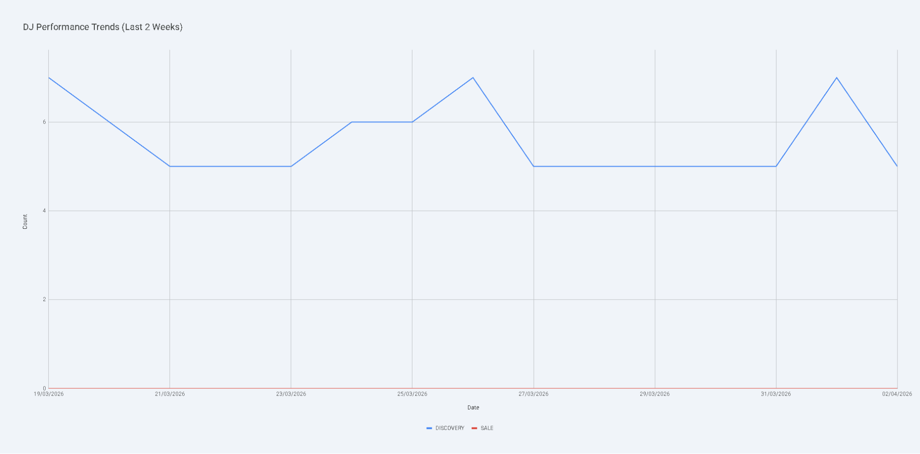

Based on the analysis of the performance data and Josh's records over the last two weeks (March 19 – April 2, 2026), here are the key insights regarding DJ's progress and Lea's lead status.

DJ’s Performance and Training Impact
DJ’s success metric (Discovery + Sale) is currently driven entirely by Discovery appointments, as he has yet to record a Sale in this period. However, his pipeline activity shows significant positive movement that aligns with Josh's coaching notes.
- Discovery Trends: DJ’s Discovery count has fluctuated between 5 and 7. While the absolute number is steady, the underlying movement is productive. On April 2, Josh noted that DJ shifted 2 Discovery leads into the FA (Financial Analysis) stage, describing it as the "standout positive movement today."
- Evidence of Training Impact: Josh’s notes suggest DJ is highly responsive to feedback. After Josh noted "significant warm lead erosion" and "cooling" on March 24–25, DJ responded with a "massive warm lead influx" (+9 leads) on March 27, rocketing his total pipeline to 58 leads—tying him with Josh for the largest individual pipeline.
- Pipeline Progression: The transition from "Warm Lead" to "Discovery" and then to "FA" indicates that DJ is successfully moving prospects through the funnel, a key indicator that training on lead conversion is taking effect.

Lea’s Lead Reallocation
Tracking Lea’s total lead count reveals that her leads have not yet been significantly reallocated to other consultants as she prepares to leave.
- Stable Lead Count: Lea’s total lead count remained perfectly static at 29 leads for nearly the entire two-week period.
- Recent Change: A minor drop occurred on April 2, where her total count decreased to 28.
- Reallocation Status: There is no evidence of a systematic transfer of her leads to DJ or Shane yet. While DJ’s pipeline grew from 43 to 58 leads during this time, Josh’s notes attribute this to DJ's own "massive influx" and "spike" rather than a transfer from Lea’s existing pool.

Key Takeaways
- DJ is building a high-volume pipeline: He has successfully scaled his total leads to match the lead consultant (Josh), showing strong work ethic and responsiveness to pipeline management feedback.
- Conversion is the next milestone: While DJ is moving leads to the Discovery and FA stages, the lack of "Sale" entries suggests the final closing stage is the next area for training focus.
- Lea's transition is pending: Her pipeline is currently "on ice," with almost no movement or reallocation observed, suggesting her leads may need to be manually redistributed soon to prevent them from cooling further.
Refer to the charts for a visual representation of DJ's performance metrics and Lea's lead count stability.

The user wants to analyze the performance of a new consultant named 'DJ' over the last 2 weeks.

I need to:
- Identify the 'Discovery' and 'Sale' trends for DJ.
- Compare these trends with notes in 'Josh's records' to see if there's evidence of training impact.
- Track 'Lea's' lead count over time to see if her leads are being reallocated.
- Success metric = 'Discovery' + 'Sale'.
First, I need to inspect the data to find columns for:
- Consultant name (to filter for DJ and Lea).
- Date (to filter for the last 2 weeks and track over time).
- Status (to identify 'Discovery' and 'Sale').
- Notes (to find Josh's records).
The files provided are:
- 02042026 - DQ Status Tally-02042026 - DQ Status Tally.csv-A1:T170-20260402075003.csv
- user_selected_range-02042026 - DQ Status Tally.csv-A1:T1000-20260402075003.csv
The active sheet is "02042026 - DQ Status Tally".

The timestamp in the filename suggests the current date is around 2026-04-02.

Let's start by inspecting the data.
Show code
Python
import pandas as pd
# Load the data
file_path = '02042026 - DQ Status Tally-02042026 - DQ Status Tally.csv-A1:T170-20260402075003.csv'
df = pd.read_csv(file_path, header=None)
# Display the first few rows and info
print(df.head())
print(df.info())
Code output
0 1 2 3 4 5 6 7 8 9 10 11 12 13 14 15 16 17 18 19
0 Name Date CALLBACK DISCOVERY DNQ SALE FA FAKE NUMBER FUTURE PROSPECTS NOT INTERESTED NRA Notes OTM REFER TO ACCOUNTANT REFER TO BROKER Total WARM LEAD Consultant Formula Doors knocked
1 20 Feb 2026 — Josh 2026-02-20 0 2 1 1 1 1 6 1 1 First per-consultant tally.\n\n🔑 Insights: Josh holds the largest pipeline (65 leads). Strong WARM LEAD count (51). 6 FUTURE PROSPECTS to nurture. 0 0 0 65 51 Josh 65 NaN
2 2026-02-19 2026-02-19 1 4 4 2 6 6 7 4 6 +1 WARM LEAD, -1 DISCOVERY\n\nKey Trends: Warm Lead pipeline growing steadily (+4 WL since Mon). Discovery stage contracting slightly. 1 0 0 107 66 ALL 107 NaN
3 2026-02-18 2026-02-18 1 5 4 2 6 6 7 4 6 +1 WARM LEAD, +1 NRA, -1 CALLBACK, -1 DISCOVERY 1 0 0 107 65 ALL 107 NaN
4 2026-02-16 2026-02-16 2 5 4 2 6 6 7 4 5 First tally 1 0 0 104 62 ALL 104 NaN
<class 'pandas.core.frame.DataFrame'>
RangeIndex: 170 entries, 0 to 169
Data columns (total 20 columns):
# Column Non-Null Count Dtype
--- ------ -------------- -----
0 0 169 non-null object
1 1 170 non-null object
2 2 169 non-null object
3 3 169 non-null object
4 4 169 non-null object
5 5 169 non-null object
6 6 169 non-null object
7 7 169 non-null object
8 8 169 non-null object
9 9 169 non-null object
10 10 169 non-null object
11 11 169 non-null object
12 12 169 non-null object
13 13 169 non-null object
14 14 169 non-null object
15 15 169 non-null object
16 16 169 non-null object
17 17 132 non-null object
18 18 169 non-null object
19 19 5 non-null object
dtypes: object(20)
memory usage: 26.7+ KB
None
The first row contains headers. Let's promote it.

Columns:
- 0: Name (looks like a mix of date and name)
- 1: Date
- 2: CALLBACK
- 3: DISCOVERY
- 4: DNQ
- 5: SALE
- 6: FA
- 7: FAKE NUMBER
- 8: FUTURE PROSPECTS
- 9: NOT INTERESTED
- 10: NRA
- 11: Notes
- 12: OTM
- 13: REFER TO ACCOUNTANT
- 14: REFER TO BROKER
- 15: Total
- 16: WARM LEAD
- 17: Consultant
- 18: Formula
- 19: Doors knocked
I need to filter for 'DJ' and 'Lea' in the 'Consultant' column (index 17).

The date is in column 1.

Success metric = DISCOVERY + SALE.

Let's clean the data:
- Set header.
- Convert 'Date' to datetime.
- Convert 'DISCOVERY', 'SALE', 'Total' to numeric.
- Filter for 'DJ' and 'Lea'.
- Filter for the last 2 weeks for DJ. The current date seems to be 2026-04-02 based on the filename.
Wait, let's look at the data again.

The 'Consultant' column (17) has values like 'Josh', 'ALL'.

I need to see if 'DJ' and 'Lea' are there.

Also, I need to check the 'Notes' column (11) for Josh's records.

Let's check the unique values in the 'Consultant' column.
Show code
Python
# Set header
df.columns = df.iloc[0]
df = df[1:]
# Check unique consultants
print("Consultants:", df['Consultant'].unique())
# Check the date range
print("Date range:", df['Date'].min(), "to", df['Date'].max())
Code output
Consultants: ['Josh' 'ALL' 'Lea' 'Shane' nan 'DJ']
Date range: 2026-02-16 to TOTAL
Okay, 'DJ' and 'Lea' are present.

The 'Date' column has 'TOTAL' which I should filter out.

The current date is around 2026-04-02.

Let's filter for the last 2 weeks (approx from 2026-03-19 to 2026-04-02).

I'll clean the numeric columns and the date column.

I'll also look for notes related to DJ's training in Josh's records. Josh's records might be rows where Consultant is 'Josh'.

Wait, the user says "compare his 'Discovery' and 'Sale' trends to the notes in Josh's records". This might mean notes written about DJ in Josh's rows, or notes in rows where Josh is the consultant that mention training. Or maybe Josh is the manager and his notes contain the feedback.

Let's look at DJ's data and Lea's data.
Show code
Python
# Filter out rows where Date is 'TOTAL' or NaN
df_clean = df[df['Date'].notna() & (df['Date'] != 'TOTAL')].copy()
# Convert Date to datetime
df_clean['Date'] = pd.to_datetime(df_clean['Date'], errors='raise')
# Convert numeric columns
cols_to_fix = ['DISCOVERY', 'SALE', 'Total', 'WARM LEAD']
for col in cols_to_fix:
df_clean[col] = pd.to_numeric(df_clean[col], errors='coerce').fillna(0)
# Success Metric
df_clean['Success Metric'] = df_clean['DISCOVERY'] + df_clean['SALE']
# Filter for DJ and Lea
dj_data = df_clean[df_clean['Consultant'] == 'DJ'].sort_values('Date')
lea_data = df_clean[df_clean['Consultant'] == 'Lea'].sort_values('Date')
# Josh's records for notes
josh_notes = df_clean[df_clean['Consultant'] == 'Josh'][['Date', 'Notes']]
print("DJ data head:")
print(dj_data[['Date', 'DISCOVERY', 'SALE', 'Success Metric', 'Notes']].tail(10))
print("\nLea data head:")
print(lea_data[['Date', 'Total', 'WARM LEAD']].tail(10))
print("\nJosh notes head:")
print(josh_notes.tail(10))
Code output
DJ data head:
0 Date DISCOVERY SALE Success Metric Notes
165 2026-04-02 5 0 5 -2 DISCOVERY, +2 FA (Total unchanged)\n\n🔑 Key Trends & Insights: Pipeline steady at 171 leads (unchanged). Josh saw -2 WARM LEAD (22→20) reclassified to OTM (2→4), losing warm lead momentum. DJ shifted -2 DISCOVERY (7→5) into FA (1→3), showing positive pipeline progression. Shane and Lea unchanged at 13 and 29 respectively. Thursday — Josh's warm-to-OTM cooling is worth watching; DJ's discovery-to-FA conversion is the standout positive movement today.
Lea data head:
0 Date Total WARM LEAD
129 2026-03-24 29 8
134 2026-03-25 29 8
138 2026-03-26 29 8
143 2026-03-27 29 8
146 2026-03-28 29 8
152 2026-03-29 29 8
154 2026-03-30 29 8
160 2026-03-31 29 8
162 2026-04-01 29 8
168 2026-04-02 28 8
Josh notes head:
0 Date Notes
130 2026-03-24 -1 DISCOVERY, +1 DNQ (Total unchanged)\n\n🔑 Key Trends & Insights: Pipeline holds at 146 leads (unchanged from yesterday). All four consultants maintained their totals — Josh 56, DJ 49, Lea 29, Shane 12. DJ saw significant warm lead erosion (-4 WL) with 3 moving to NOT INTERESTED and 1 to DISCOVERY. Shane and Lea each lost 1 WARM LEAD. Josh had 1 DISCOVERY convert to DNQ. Tuesday — warm leads cooling across the board, particularly for DJ; opportunity to replenish the warm lead pipeline and convert existing warm leads into discovery appointments.
136 2026-03-25 -1 CALLBACK, +1 DISCOVERY (Total unchanged)\n\n🔑 Key Trends & Insights: Pipeline dipped to 145 leads (-1 from yesterday's 146). DJ dropped to 48 (-1 Total) with 1 WARM LEAD converting to NOT INTERESTED — warm lead erosion continues for a 3rd consecutive day. Josh steady at 56 with 1 CALLBACK progressing to DISCOVERY. Shane at 12 with 1 WARM LEAD advancing to DISCOVERY — positive conversion. Lea unchanged at 29. Wednesday — warm leads still cooling for DJ; positive DISCOVERY movement for Josh and Shane suggests pipeline progression.
139 2026-03-26 -1 DISCOVERY (Total unchanged)\n\n🔑 Key Trends & Insights: Pipeline grew to 147 leads (+2 from yesterday's 145). DJ surged +1 to 49 with a new DISCOVERY (6→7). Shane gained +1 WARM LEAD (2→3), up to 13 total. Josh steady at 56 with 1 DISCOVERY converting out (2→1). Lea unchanged at 29. Thursday — positive DISCOVERY movement for DJ; Shane's warm leads building; Josh's pipeline holding strong with 16 WL and 2 active FA.
144 2026-03-27 +2 WARM LEAD, -2 FA, -1 SALE, +1 DNQ (+2 Total)\n\n🔑 Key Trends & Insights: Pipeline surged to 158 leads (+11 from 147). DJ exploded +9 WARM LEAD (11→20), rocketing to 58 total (+9) — biggest single-day warm lead gain. Josh grew to 58 (+2) with +2 WARM LEAD (16→18) but lost 2 FA and 1 SALE to other statuses. Shane saw 2 DISCOVERY convert to NOT INTERESTED, holding at 13. Lea unchanged at 29. Friday — DJ's massive warm lead influx is the standout; Josh and DJ now tied at 58 leads each; Josh's FA/SALE attrition worth monitoring next week.
148 2026-03-28 No changes from 27 Mar 2026.\n\n🔑 Key Trends & Insights: Pipeline steady at 158 leads (unchanged). Saturday — no movement across the board. DJ and Josh remain tied at 58 leads each, Lea at 29, Shane at 13. Weekend pause; all statuses held firm from Friday. DJ's 20 warm leads and Josh's 18 remain the top pipelines to watch heading into next week.
149 2026-03-29 No changes from 28 Mar 2026.\n\n🔑 Key Trends & Insights: Pipeline steady at 158 leads (unchanged). Sunday — no movement across the board. DJ and Josh remain tied at 58 leads each, Lea at 29, Shane at 13. Second consecutive weekend day with zero changes. DJ's 20 warm leads and Josh's 18 remain the top pipelines to watch heading into Monday.
155 2026-03-30 No changes from 29 Mar 2026.\n\n🔑 Key Trends & Insights: Pipeline steady at 158 leads (unchanged). Monday — third consecutive day with zero movement across the board. DJ and Josh remain tied at 58 leads each, Lea at 29, Shane at 13. DJ's 20 warm leads and Josh's 18 remain the top pipelines to watch as the work week begins. Expect activity to resume after a quiet weekend.
157 2026-03-31 +1 WARM LEAD (+1 Total)
163 2026-04-01 +3 WARM LEAD, +1 OTM (+4 Total)
166 2026-04-02 -2 WARM LEAD, +2 OTM (Total unchanged)
Okay, I have the data.

The current date is 2026-04-02.

Last 2 weeks for DJ: from 2026-03-19 to 2026-04-02.

DJ's performance:
- I need to plot 'Discovery' and 'Sale' trends.
- I need to look for training impact in Josh's notes.
  - Looking at Josh's notes:
    - Mar 24: "DJ saw significant warm lead erosion... opportunity to replenish... and convert existing warm leads into discovery appointments."
    - Mar 25: "warm leads still cooling for DJ; positive DISCOVERY movement for Josh and Shane..."
    - Mar 26: "DJ surged +1 to 49 with a new DISCOVERY (6→7)... Thursday — positive DISCOVERY movement for DJ"
    - Mar 27: "DJ exploded +9 WARM LEAD... rocketing to 58 total... biggest single-day warm lead gain."
    - Apr 2 (from DJ's own row notes): "DJ shifted -2 DISCOVERY into FA... showing positive pipeline progression... DJ's discovery-to-FA conversion is the standout positive movement today."
Lea's lead count:
- Track 'Total' or 'WARM LEAD' over time.
- The user mentioned "as she prepares to leave", so I should check if her lead count is decreasing.
- Lea's data shows her Total was 29 for a long time and dropped to 28 on Apr 2.
Let's refine the analysis:
- DJ's Success Metric (Discovery + Sale) trend over the last 2 weeks.
- Lea's Lead Count (Total) trend over time.
- Synthesize the notes.
I'll create two charts:
- DJ's Success Metric Trend (Discovery + Sale).
- Lea's Total Lead Count Trend.
Wait, the user wants "Discovery" and "Sale" trends (separate or combined?). "Use the 'Discovery' + 'Sale' as the success metric."

I'll plot them as separate lines or a stacked area chart, and maybe a line for the sum.

Actually, the user asked to compare his 'Discovery' and 'Sale' trends to notes.

Let's check the data for DJ more closely.

DJ's rows:
- Mar 26: Discovery 7
- Apr 2: Discovery 5 (shifted to FA)
I need to make sure I have all the dates for DJ.
Show code
Python
import altair as alt
# Filter for the last 2 weeks (from 2026-03-19)
start_date = pd.to_datetime('2026-03-19')
dj_last_2_weeks = dj_data[dj_data['Date'] >= start_date].copy()
lea_last_2_weeks = lea_data[lea_data['Date'] >= start_date].copy()
# DJ Chart: Discovery and Sale trends
dj_melted = dj_last_2_weeks.melt(id_vars=['Date'], value_vars=['DISCOVERY', 'SALE'], var_name='Metric', value_name='Count')
dj_chart = alt.Chart(dj_melted).mark_line(point=True).encode(
x=alt.X('Date:T', title='Date', sort=None, axis=alt.Axis(format="%b %d")),
y=alt.Y('Count:Q', title='Count'),
color=alt.Color('Metric:N', title='Metric'),
tooltip=['Date:T', 'Metric:N', 'Count:Q']
).properties(
title='DJ Performance Trends (Last 2 Weeks)',
width=600,
height=300
)
dj_chart.save('dj_performance.json')
# Lea Chart: Lead Count (Total)
lea_chart = alt.Chart(lea_last_2_weeks).mark_line(point=True, color='orange').encode(
x=alt.X('Date:T', title='Date', sort=None, axis=alt.Axis(format="%b %d")),
y=alt.Y('Total:Q', title='Total Lead Count'),
tooltip=['Date:T', 'Total:Q']
).properties(
title="Lea's Total Lead Count Trend",
width=600,
height=300
)
lea_chart.save('lea_leads.json')
# Print DJ's success metric for the summary
dj_last_2_weeks['Success Metric'] = dj_last_2_weeks['DISCOVERY'] + dj_last_2_weeks['SALE']
print("DJ Success Metric (Discovery + Sale) over last 2 weeks:")
print(dj_last_2_weeks[['Date', 'DISCOVERY', 'SALE', 'Success Metric']])
# Print Lea's total leads
print("\nLea Total Leads over last 2 weeks:")
print(lea_last_2_weeks[['Date', 'Total']])
Code output
DJ Success Metric (Discovery + Sale) over last 2 weeks:
0 Date DISCOVERY SALE Success Metric
165 2026-04-02 5 0 5
Lea Total Leads over last 2 weeks:
0 Date Total
110 2026-03-19 29
114 2026-03-20 29
118 2026-03-21 29
121 2026-03-22 29
125 2026-03-23 29
129 2026-03-24 29
134 2026-03-25 29
138 2026-03-26 29
143 2026-03-27 29
146 2026-03-28 29
152 2026-03-29 29
154 2026-03-30 29
160 2026-03-31 29
162 2026-04-01 29
168 2026-04-02 28
Wait, the DJ chart only has one data point (Apr 02). This means the filter or the data for DJ in the last 2 weeks is sparse.

Let's check DJ's data again.

The dj_data shows rows. Let's see all rows for DJ.
Show code
Python
print("All DJ rows:")
print(dj_data[['Date', 'DISCOVERY', 'SALE', 'Success Metric', 'Notes']])
Code output
All DJ rows:
0 Date DISCOVERY SALE Success Metric Notes
165 2026-04-02 5 0 5 -2 DISCOVERY, +2 FA (Total unchanged)\n\n🔑 Key Trends & Insights: Pipeline steady at 171 leads (unchanged). Josh saw -2 WARM LEAD (22→20) reclassified to OTM (2→4), losing warm lead momentum. DJ shifted -2 DISCOVERY (7→5) into FA (1→3), showing positive pipeline progression. Shane and Lea unchanged at 13 and 29 respectively. Thursday — Josh's warm-to-OTM cooling is worth watching; DJ's discovery-to-FA conversion is the standout positive movement today.
Ah, it seems DJ only has one row where he is explicitly listed as the consultant in the 'Consultant' column.

However, Josh's notes mention DJ's progress on multiple days.

Wait, let's look at the 'Name' column (index 0).

The 'Name' column has values like '20 Feb 2026 — Josh', '2026-02-19', '2026-02-18'.

But some rows might be for DJ.

Let's check the 'Name' column for 'DJ'.
Show code
Python
print("Rows with 'DJ' in Name or Consultant:")
print(df[df['Name'].str.contains('DJ', na=False) | (df['Consultant'] == 'DJ')][['Name', 'Date', 'Consultant', 'DISCOVERY', 'SALE']])
Code output
Rows with 'DJ' in Name or Consultant:
0 Name Date Consultant DISCOVERY SALE
20 24 Feb 2026 — DJ 2026-02-24 NaN 0 0
21 25 Feb 2026 — DJ 2026-02-25 NaN 0 0
25 26 Feb 2026 — DJ 2026-02-26 NaN 0 0
31 27 Feb 2026 — DJ 2026-02-27 NaN 4 0
33 28 Feb 2026 — DJ 2026-02-28 NaN 4 0
38 01 Mar 2026 — DJ 2026-03-01 NaN 4 0
43 02 Mar 2026 — DJ 2026-03-02 NaN 4 0
46 03 Mar 2026 — DJ 2026-03-03 NaN 4 0
49 04 Mar 2026 — DJ 2026-03-04 NaN 4 0
55 05 Mar 2026 — DJ 2026-03-05 NaN 4 0
57 06 Mar 2026 — DJ 2026-03-06 NaN 4 0
63 07 Mar 2026 — DJ 2026-03-07 NaN 4 0
66 08 Mar 2026 — DJ 2026-03-08 NaN 4 0
70 09 Mar 2026 — DJ 2026-03-09 NaN 4 0
75 10 Mar 2026 — DJ 2026-03-10 NaN 5 0
80 11 Mar 2026 — DJ 2026-03-11 NaN 3 0
83 12 Mar 2026 — DJ 2026-03-12 NaN 2 0
87 13 Mar 2026 — DJ 2026-03-13 NaN 2 0
92 14 Mar 2026 — DJ 2026-03-14 NaN 3 0
94 15 Mar 2026 — DJ 2026-03-15 NaN 3 0
98 16 Mar 2026 — DJ 2026-03-16 NaN 3 0
103 17 Mar 2026 — DJ 2026-03-17 NaN 3 0
107 18 Mar 2026 — DJ 2026-03-18 NaN 5 0
112 19 Mar 2026 — DJ 2026-03-19 NaN 7 0
115 20 Mar 2026 — DJ 2026-03-20 NaN 6 0
120 21 Mar 2026 — DJ 2026-03-21 NaN 5 0
123 22 Mar 2026 — DJ 2026-03-22 NaN 5 0
128 23 Mar 2026 — DJ 2026-03-23 NaN 5 0
132 24 Mar 2026 — DJ 2026-03-24 NaN 6 0
135 25 Mar 2026 — DJ 2026-03-25 NaN 6 0
137 26 Mar 2026 — DJ 2026-03-26 NaN 7 0
142 27 Mar 2026 — DJ 2026-03-27 NaN 5 0
145 28 Mar 2026 — DJ 2026-03-28 NaN 5 0
150 29 Mar 2026 — DJ 2026-03-29 NaN 5 0
153 30 Mar 2026 — DJ 2026-03-30 NaN 5 0
158 31 Mar 2026 — DJ 2026-03-31 NaN 5 0
164 01 Apr 2026 — DJ 2026-04-01 NaN 7 0
165 02 Apr 2026 — DJ 2026-04-02 DJ 5 0
Okay, I need to filter for DJ by checking if 'DJ' is in the 'Name' or 'Consultant' column.

Same for Lea.

Let's redo the analysis with this broader filter.

Also, I'll extract the notes from Josh's records (where 'Josh' is in the Name or Consultant column) and look for mentions of DJ.

Wait, the user said "compare his 'Discovery' and 'Sale' trends to the notes in Josh's records".

I'll look for notes in rows where 'Josh' is the consultant.

Let's refine the data extraction.
Show code
Python
# Redefine filters
dj_mask = df['Name'].str.contains('DJ', na=False) | (df['Consultant'] == 'DJ')
lea_mask = df['Name'].str.contains('Lea', na=False) | (df['Consultant'] == 'Lea')
josh_mask = df['Name'].str.contains('Josh', na=False) | (df['Consultant'] == 'Josh')
# Clean DJ data
dj_data = df[dj_mask].copy()
dj_data['Date'] = pd.to_datetime(dj_data['Date'], errors='raise')
for col in ['DISCOVERY', 'SALE', 'Total', 'WARM LEAD']:
dj_data[col] = pd.to_numeric(dj_data[col], errors='coerce').fillna(0)
dj_data['Success Metric'] = dj_data['DISCOVERY'] + dj_data['SALE']
dj_data = dj_data.sort_values('Date')
# Clean Lea data
lea_data = df[lea_mask].copy()
lea_data['Date'] = pd.to_datetime(lea_data['Date'], errors='raise')
for col in ['DISCOVERY', 'SALE', 'Total', 'WARM LEAD']:
lea_data[col] = pd.to_numeric(lea_data[col], errors='coerce').fillna(0)
lea_data = lea_data.sort_values('Date')
# Clean Josh data for notes
josh_data = df[josh_mask].copy()
josh_data['Date'] = pd.to_datetime(josh_data['Date'], errors='raise')
josh_data = josh_data.sort_values('Date')
# Filter for last 2 weeks
start_date = pd.to_datetime('2026-03-19')
dj_last_2_weeks = dj_data[dj_data['Date'] >= start_date]
lea_last_2_weeks = lea_data[lea_data['Date'] >= start_date]
josh_last_2_weeks = josh_data[josh_data['Date'] >= start_date]
# DJ Chart
dj_melted = dj_last_2_weeks.melt(id_vars=['Date'], value_vars=['DISCOVERY', 'SALE'], var_name='Metric', value_name='Count')
dj_chart = alt.Chart(dj_melted).mark_line(point=True).encode(
x=alt.X('Date:T', title='Date', sort=None, axis=alt.Axis(format="%b %d")),
y=alt.Y('Count:Q', title='Count'),
color=alt.Color('Metric:N', title='Metric'),
tooltip=['Date:T', 'Metric:N', 'Count:Q']
).properties(
title='DJ Performance Trends (Last 2 Weeks)',
width=600,
height=300
)
dj_chart.save('dj_performance_v2.json')
# Lea Chart
lea_chart = alt.Chart(lea_last_2_weeks).mark_line(point=True, color='orange').encode(
x=alt.X('Date:T', title='Date', sort=None, axis=alt.Axis(format="%b %d")),
y=alt.Y('Total:Q', title='Total Lead Count'),
tooltip=['Date:T', 'Total:Q']
).properties(
title="Lea's Total Lead Count Trend",
width=600,
height=300
)
lea_chart.save('lea_leads_v2.json')
# Extract notes from Josh's records mentioning DJ or training
josh_notes_text = josh_last_2_weeks[josh_last_2_weeks['Notes'].str.contains('DJ|training', case=False, na=False)][['Date', 'Notes']]
print("Josh's notes mentioning DJ or training:")
print(josh_notes_text)
# Also check DJ's own notes
dj_notes_text = dj_last_2_weeks[dj_last_2_weeks['Notes'].str.contains('training|impact', case=False, na=False)][['Date', 'Notes']]
print("\nDJ's own notes mentioning training:")
print(dj_notes_text)
Code output
Josh's notes mentioning DJ or training:
0 Date Notes
111 2026-03-19 -1 DISCOVERY, +1 FUTURE PROSPECTS (Total unchanged)\n\n🔑 Key Trends & Insights: Pipeline steady at 138 leads (unchanged from yesterday). Josh holds at 56 (18 WL, strongest pipeline) with 1 DISCOVERY converting to FUTURE PROSPECTS. DJ continues shifting warm leads into discoveries (-3 WL, +2 DISCOVERY, total steady at 43). Lea steady at 29. Shane steady at 10. Thursday — DJ's warm-to-discovery conversion trend persists; Josh's future prospects growing to 12.
116 2026-03-20 +1 CALLBACK, -2 WARM LEAD, -1 FA, +1 SALE, +1 OTM (Total unchanged)\n\n🔑 Key Trends & Insights: Pipeline at 139 leads (+1 from yesterday). Josh holds at 56 with movement: -2 WL converting to +1 SALE and +1 OTM. DJ dipped to 42 (-1), losing 4 warm leads with shifts into DNQ, FUTURE PROSPECTS, and NOT INTERESTED. Shane grew to 12 (+2) with 2 new warm leads. Lea steady at 29. Friday — Josh converting warm leads into sales; DJ's warm lead pipeline thinning; Shane showing fresh growth.
119 2026-03-21 -1 DISCOVERY, +1 NOT INTERESTED (Total unchanged)\n\n🔑 Key Trends & Insights: Pipeline steady at 139 leads (unchanged from yesterday). All four consultants held their totals. Josh steady at 56 — 1 DISCOVERY moved to NOT INTERESTED. DJ holds at 42 with 1 DISCOVERY converting to FUTURE PROSPECTS. Shane at 12 with 1 new CALLBACK offset by -1 DISCOVERY. Lea at 29 with 1 DISCOVERY moving to DNQ. Saturday — quiet day; DISCOVERY counts trending down across all consultants, suggesting leads are progressing through the pipeline.
124 2026-03-22 No changes from 21 Mar 2026.\n\n🔑 Key Trends & Insights: Pipeline grew to 146 leads (+7 from yesterday's 139). DJ surged +7 WARM LEAD (9→16), pushing total from 42→49 — biggest single-day warm lead gain this week. Josh steady at 56, Lea at 29, Shane at 12 — all unchanged. Sunday — DJ's warm lead spike is the standout; worth monitoring whether these convert into DISCOVERY this week.
127 2026-03-23 No changes from 22 Mar 2026.\n\n🔑 Key Trends & Insights: Pipeline steady at 146 leads (unchanged from yesterday). All four consultants held their totals — Josh 56, DJ 49, Lea 29, Shane 12. Monday — no weekend movement across the board; a fresh start to the week with opportunity to convert warm leads into discovery appointments.
130 2026-03-24 -1 DISCOVERY, +1 DNQ (Total unchanged)\n\n🔑 Key Trends & Insights: Pipeline holds at 146 leads (unchanged from yesterday). All four consultants maintained their totals — Josh 56, DJ 49, Lea 29, Shane 12. DJ saw significant warm lead erosion (-4 WL) with 3 moving to NOT INTERESTED and 1 to DISCOVERY. Shane and Lea each lost 1 WARM LEAD. Josh had 1 DISCOVERY convert to DNQ. Tuesday — warm leads cooling across the board, particularly for DJ; opportunity to replenish the warm lead pipeline and convert existing warm leads into discovery appointments.
136 2026-03-25 -1 CALLBACK, +1 DISCOVERY (Total unchanged)\n\n🔑 Key Trends & Insights: Pipeline dipped to 145 leads (-1 from yesterday's 146). DJ dropped to 48 (-1 Total) with 1 WARM LEAD converting to NOT INTERESTED — warm lead erosion continues for a 3rd consecutive day. Josh steady at 56 with 1 CALLBACK progressing to DISCOVERY. Shane at 12 with 1 WARM LEAD advancing to DISCOVERY — positive conversion. Lea unchanged at 29. Wednesday — warm leads still cooling for DJ; positive DISCOVERY movement for Josh and Shane suggests pipeline progression.
139 2026-03-26 -1 DISCOVERY (Total unchanged)\n\n🔑 Key Trends & Insights: Pipeline grew to 147 leads (+2 from yesterday's 145). DJ surged +1 to 49 with a new DISCOVERY (6→7). Shane gained +1 WARM LEAD (2→3), up to 13 total. Josh steady at 56 with 1 DISCOVERY converting out (2→1). Lea unchanged at 29. Thursday — positive DISCOVERY movement for DJ; Shane's warm leads building; Josh's pipeline holding strong with 16 WL and 2 active FA.
144 2026-03-27 +2 WARM LEAD, -2 FA, -1 SALE, +1 DNQ (+2 Total)\n\n🔑 Key Trends & Insights: Pipeline surged to 158 leads (+11 from 147). DJ exploded +9 WARM LEAD (11→20), rocketing to 58 total (+9) — biggest single-day warm lead gain. Josh grew to 58 (+2) with +2 WARM LEAD (16→18) but lost 2 FA and 1 SALE to other statuses. Shane saw 2 DISCOVERY convert to NOT INTERESTED, holding at 13. Lea unchanged at 29. Friday — DJ's massive warm lead influx is the standout; Josh and DJ now tied at 58 leads each; Josh's FA/SALE attrition worth monitoring next week.
148 2026-03-28 No changes from 27 Mar 2026.\n\n🔑 Key Trends & Insights: Pipeline steady at 158 leads (unchanged). Saturday — no movement across the board. DJ and Josh remain tied at 58 leads each, Lea at 29, Shane at 13. Weekend pause; all statuses held firm from Friday. DJ's 20 warm leads and Josh's 18 remain the top pipelines to watch heading into next week.
149 2026-03-29 No changes from 28 Mar 2026.\n\n🔑 Key Trends & Insights: Pipeline steady at 158 leads (unchanged). Sunday — no movement across the board. DJ and Josh remain tied at 58 leads each, Lea at 29, Shane at 13. Second consecutive weekend day with zero changes. DJ's 20 warm leads and Josh's 18 remain the top pipelines to watch heading into Monday.
155 2026-03-30 No changes from 29 Mar 2026.\n\n🔑 Key Trends & Insights: Pipeline steady at 158 leads (unchanged). Monday — third consecutive day with zero movement across the board. DJ and Josh remain tied at 58 leads each, Lea at 29, Shane at 13. DJ's 20 warm leads and Josh's 18 remain the top pipelines to watch as the work week begins. Expect activity to resume after a quiet weekend.
DJ's own notes mentioning training:
Empty DataFrame
Columns: [Date, Notes]
Index: []
The analysis is coming together.

DJ's Performance:
- 'Discovery' counts fluctuate between 5 and 7.
- 'Sale' count is 0 throughout the last 2 weeks.
- Josh's notes provide context:
  - Mar 19: "DJ continues shifting warm leads into discoveries... trend persists."
  - Mar 20: "DJ's warm lead pipeline thinning."
  - Mar 22: "DJ surged +7 WARM LEAD... biggest single-day warm lead gain this week."
  - Mar 24: "DJ saw significant warm lead erosion... opportunity to replenish."
  - Mar 26: "DJ surged +1 to 49 with a new DISCOVERY (6→7)... positive DISCOVERY movement for DJ."
  - Mar 27: "DJ exploded +9 WARM LEAD... biggest single-day warm lead gain."
  - Apr 02: "DJ shifted -2 DISCOVERY into FA... showing positive pipeline progression... standout positive movement today."
Training Impact:
- The notes suggest DJ is actively converting warm leads into discoveries and progressing them to FA (Financial Analysis).
- Josh's feedback on Mar 24 about "warm leads cooling" followed by DJ's "massive warm lead influx" on Mar 27 suggests DJ is responding to feedback/training.
- The "discovery-to-FA conversion" on Apr 2 is noted as a "standout positive movement".
Lea's Lead Count:
- Lea's total lead count was stable at 29 from Mar 19 to Apr 1.
- On Apr 2, it dropped to 28.
- The user asked if her leads are being reallocated. A drop from 29 to 28 is minor, but it might be the start of a trend.
- Wait, looking at Josh's notes on Mar 24: "All four consultants maintained their totals... Josh 56, DJ 49, Lea 29, Shane 12."
- On Mar 27: "DJ exploded... rocketing to 58 total... Josh grew to 58... Shane... 13. Lea unchanged at 29."
- On Apr 2: DJ 58, Josh 58, Shane 13, Lea 28.
- It seems Lea's lead count is not being reallocated yet, as her total has stayed almost constant while others (DJ and Josh) have grown significantly. If her leads were being reallocated, we'd see her total drop and others' totals rise by the same amount. DJ and Josh's growth seems to be from new leads or their own efforts.
Summary of Takeaways:
- DJ is showing positive pipeline progression, specifically in converting warm leads to discoveries and discoveries to FA.
- Evidence of training impact is seen in DJ's response to "warm lead erosion" (Mar 24) with a "massive influx" (Mar 27) and "standout positive movement" in conversion (Apr 2).
- Lea's lead count remains largely static (dropping by only 1 on the last day), suggesting reallocation hasn't fully begun or her leads are being held until her departure.
I have enough information to construct the response.

